Sql assignment: 2

Sql assignment 2: restaurant and select form table

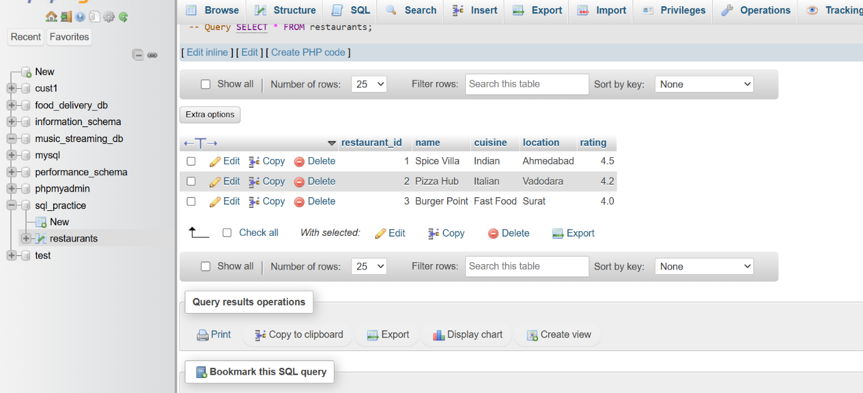

Sql assignment 2: ratings of restaurants
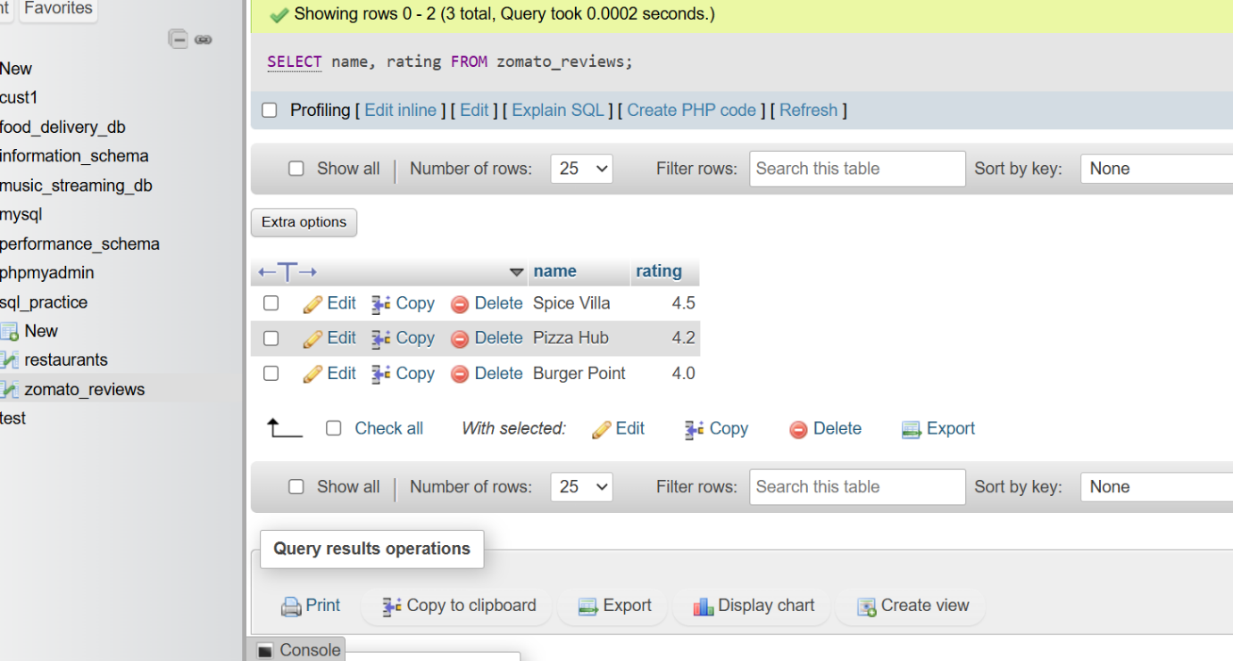

Sql assignment 2: movies sql
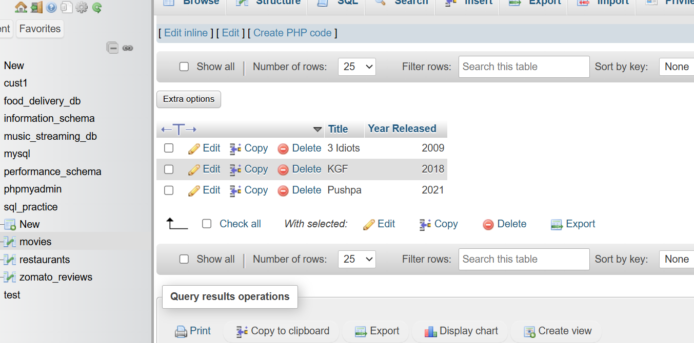

Sql assignment 2: products query
